Case Study: Bank Fund Transfer Application

Project Overview
As part of this training, participants will develop a production-oriented Bank Fund Transfer REST API using modern Java and Spring Boot.
The project will evolve incrementally from a basic application into a tested, documented and quality-checked backend application, following practices used in enterprise Java development.

Business Scenario
Build a backend service that allows customers to:
- View bank accounts
- Retrieve an account by ID
- Transfer funds between accounts
- Validate business rules
- Handle business and technical exceptions
- Persist account data in MySQL

Application Flow

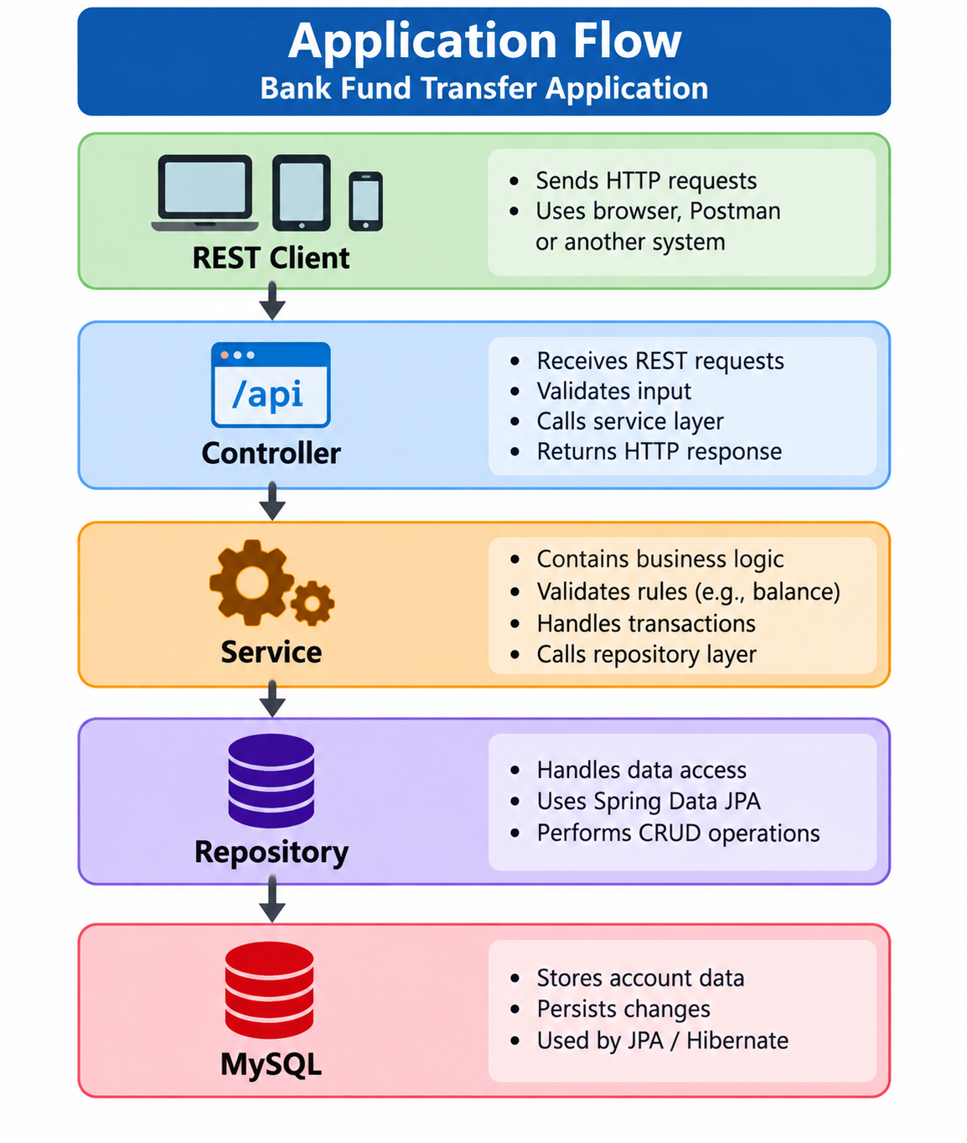

Technology Stack
Category | Technology
Language | Java 21
Framework | Spring Boot
API | REST / Spring MVC
Persistence | Spring Data JPA / Hibernate
Database | MySQL
Build | Maven
Unit Testing | JUnit 5 + Mockito
Web Testing | MockMvc / @WebMvcTest
Integration Testing | @SpringBootTest
Database Testing | Testcontainers + MySQL
Code Coverage | JaCoCo
Code Quality | SonarQube
API Documentation | Swagger / OpenAPI
Infrastructure | Docker

Key Engineering Practices
Participants will apply:
- Object-oriented design
- Layered architecture
- Dependency Injection
- DTOs and exception handling
- Transaction management
- REST API design
- Unit and integration testing
- Code coverage and static analysis
- Containerized testing

Testing & Quality Pipeline

The project specifically progresses from unit and layer-level testing toward integration testing with a real MySQL database through Testcontainers.
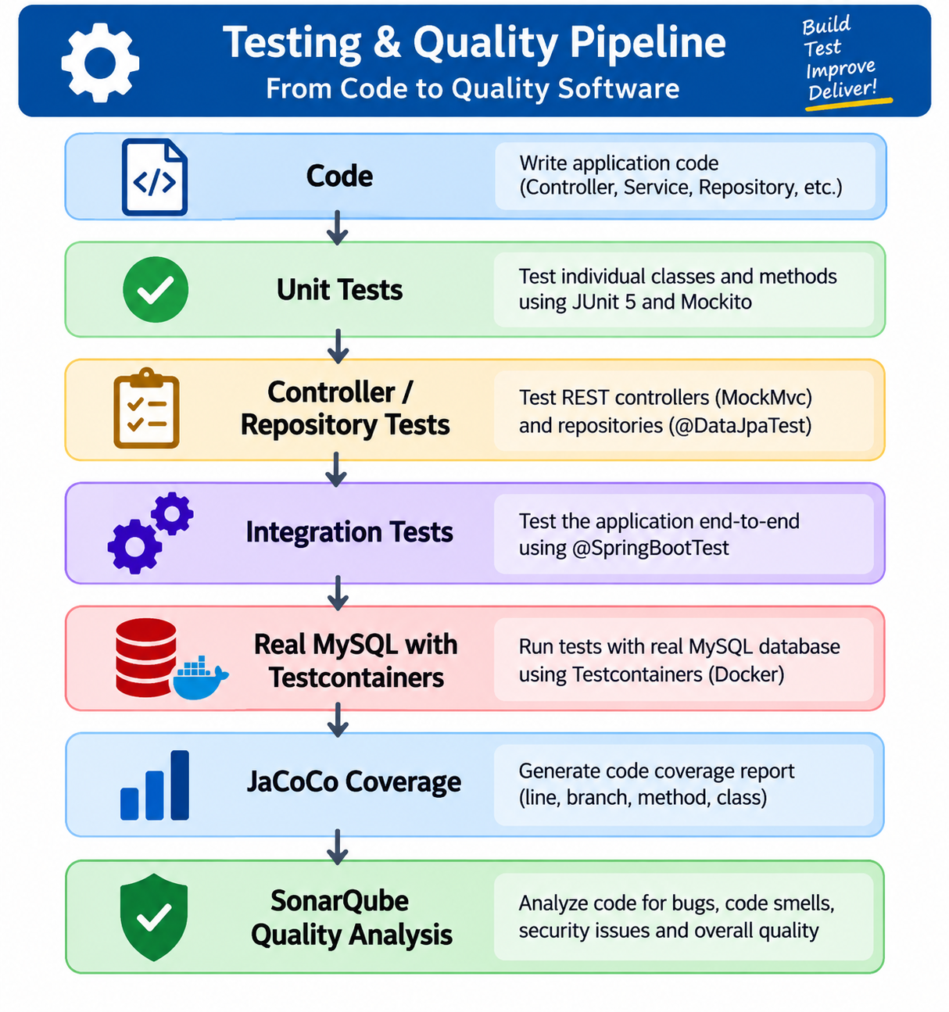

Participant Deliverables
By the end of the case study, participants will deliver:
- Complete Java 21 Spring Boot application
- Working REST APIs
- MySQL + JPA/Hibernate integration
- Business exception handling
- JUnit 5 + Mockito test suite
- Controller and repository tests
- Integration tests using Testcontainers + MySQL
- JaCoCo code coverage report
- SonarQube quality analysis
- Swagger/OpenAPI API documentation
- Docker-based supporting environment
- Project README with build, run and test instructions

Expected Outcome
At the completion of the case study, participants should be able to:
Design, develop, test, document and quality-check a Java 21 Spring Boot backend application using enterprise development practices.
Final Deliverable:

A working, tested, documented and quality-checked Bank Fund Transfer REST API.

